Section A
- Which correctly shows the relationship between pressure and depth in a liquid?

Tick (✓) one box.

The pressure increases with depth under the surface | 
The pressure decreases with depth under the surface
The pressure does not change with depth
- Which correctly shows the relationship between pressure and altitude?

Tick (✓) one box.

The pressure increases with altitude
The pressure decreases with altitude
The pressure does not change with altitude

Section B
- A child is collecting dive sticks from the bottom of a swimming pool.
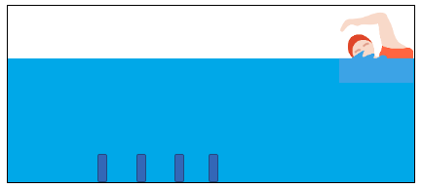

- Describe what happens to the pressure on the child as they swim to the bottom of the pool. Explain why.

___________________________________________________________________________________

___________________________________________________________________________________

___________________________________________________________________________________

___________________________________________________________________________________
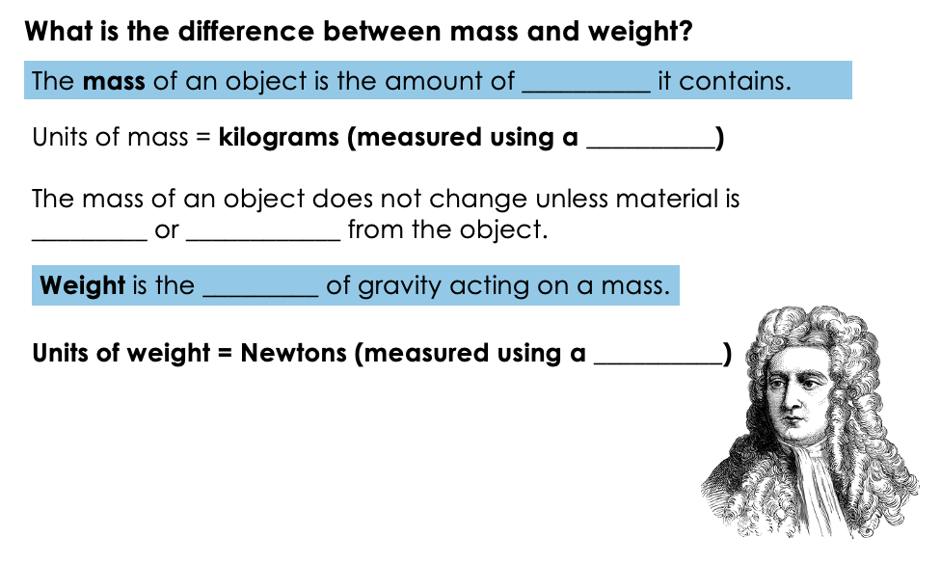

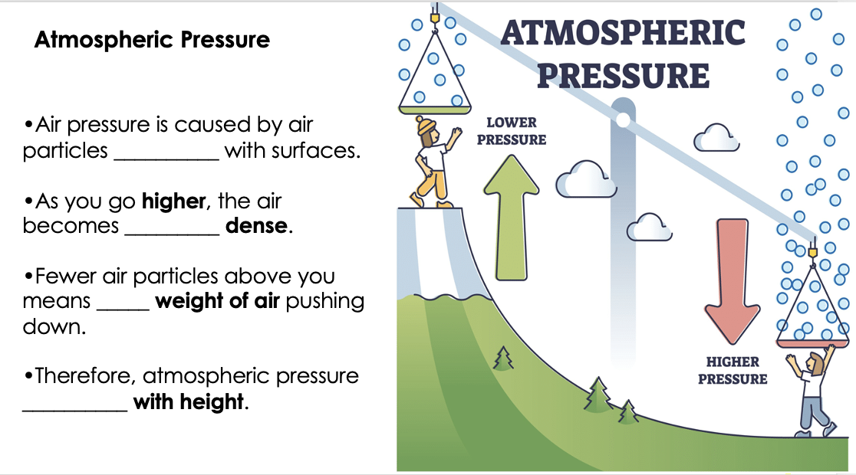

Key Ideas
- Pressure in a liquid increase with depth.
- Pressure is greater in denser liquids (like syrup vs water).
- A larger area gives a larger force when pressure is the same.

1. A ball has a mass of 4 kg. Use g = 10 N/kg.
Calculate the weight.

W = ___________________

2. A dog has a mass of 7 kg. Use g = 10 N/kg.
Calculate the weight.

W = ___________________

3. A helmet has a mass of 1.5 kg. Use g = 10 N/kg.
Calculate the weight.

W = ___________________

4. The weight of an object is 50 N. Use g = 10 N/kg.
Find the mass.

m = ___________________

5. The weight of a rock is 120 N. Use g = 10 N/kg.
Find the mass.

m = ___________________

6. A box has a mass of 5 kg and a weight of 50 N.
Find g.
g = ___________________

7. An object has a mass of 2 kg and a weight of 20 N.
Find g.
g = ___________________

